Name: P V GIRIDHAR
Reg. No: 1972260022
Exercise 1
AIM:
To write a Python program using NumPy arrays to calculate the average score of each subject (Math, Science, English and History) from a 4x4 matrix of student marks, and to identify the subject with the highest average score.
ALGORITHM:
Step 1: Start.
Step 2: Import the NumPy library.
Step 3: Create the 4x4 matrix student_scores (rows = students, columns = Math, Science, English, History).
Step 4: Store the subject names Math, Science, English and History in a list.
Step 5: Calculate the mean of every column to get the average score of each subject.
Step 6: Find the position of the largest average value.
Step 7: Use that position to get the name of the subject with the highest average.
Step 8: Display the matrix, the average of each subject and the subject with the highest average.
Step 9: Stop.
PROCEDURE:
- Import the NumPy library as np.
- Create the 4x4 array student_scores using np.array(), where each row represents a student and each column represents a subject.
- Store the subject names in a list in the same order as the columns.
- Calculate the average score of each subject (column-wise) using np.mean(student_scores, axis=0).
- Find the index of the highest average using np.argmax() and read the subject name from the list.
- Print the matrix, the average of each subject and the subject with the highest average.
INPUT AND OUTPUT:
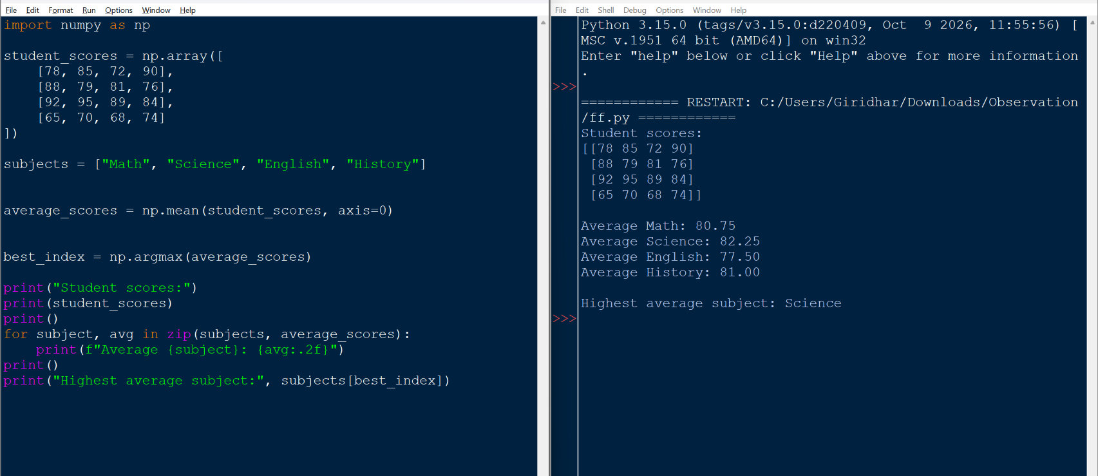
RESULT:
The average scores are Math = 80.75, Science = 82.25, English = 77.50 and History = 81.00. Science has the highest average score (82.25). Thus the program was executed successfully and the output was verified.

